Local Author Visit and Free Books
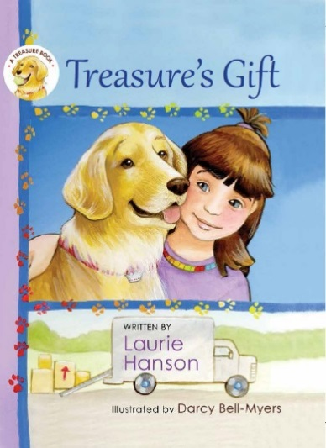
Hello, my name is Laurie Hanson, and I live in Ramsey. I recently wrote and published a children’s book called “Treasure’s Gift” about a Golden Retriever. I have been given a great opportunity by the Ramsey Lions to present my book to schools in the city of Ramsey. I would love to come to your classroom and read my book to your students and answer any questions they have about the book, about dogs, and about how to write a book.

Afterwards, I will present – free of charge – a signed book for your classroom, and a signed book you can give away to one of your students.

To schedule a classroom visit, you can contact me at kimtuck@comcast.net, or call me at 763-323-0118.
You can also visit LaurieHansonBooks.com for more information.

“Treasure’s Gift” is an illustrated hardcover childrens book appropriate for young readers. It is a story about a young girl who owns a dog; and has to deal with moving to a new neighborhood and the challenge of finding new friends. It is a winner of the 2017 Purple Dragonfly award for Childrens Books.

School visits and book donations are made possible by a grant from the Ramsey Lions.

